Places of Interests in Shanghai

As we all know, Shanghai is the largest economy of China, and its daily throughput is among the highest in the world. With the huge population movement, the development of tourism plays a vital role for Shanghai. Below we use three layers to visualize the nature of many tourist attractions in Shanghai.

In the first layer, it shows the geographical distribution of major scenic spots in Shanghai. We divide the attractions into three parts according to accessibility of major transportation facilities, that is, the time range for tourists from arriving in Shanghai to arriving at the scenic spots:

We divide it into three categories through accessibility. The first category has the highest score, which is represented by the red dot and the maximum radius. It combines the accessibility of the three major transportation of the airport, railway station, and bus station. Its convenience is the highest for tourists, and it is the most suitable for them as the first stop to visit after arrival. From red to yellow to blue, the accessibility of major transportation facilities is getting lower and lower. The blue dot has the lowest connection with external transportation facilities, which can be found that most of them are distributed outside the city, so it is suitable for local residents.

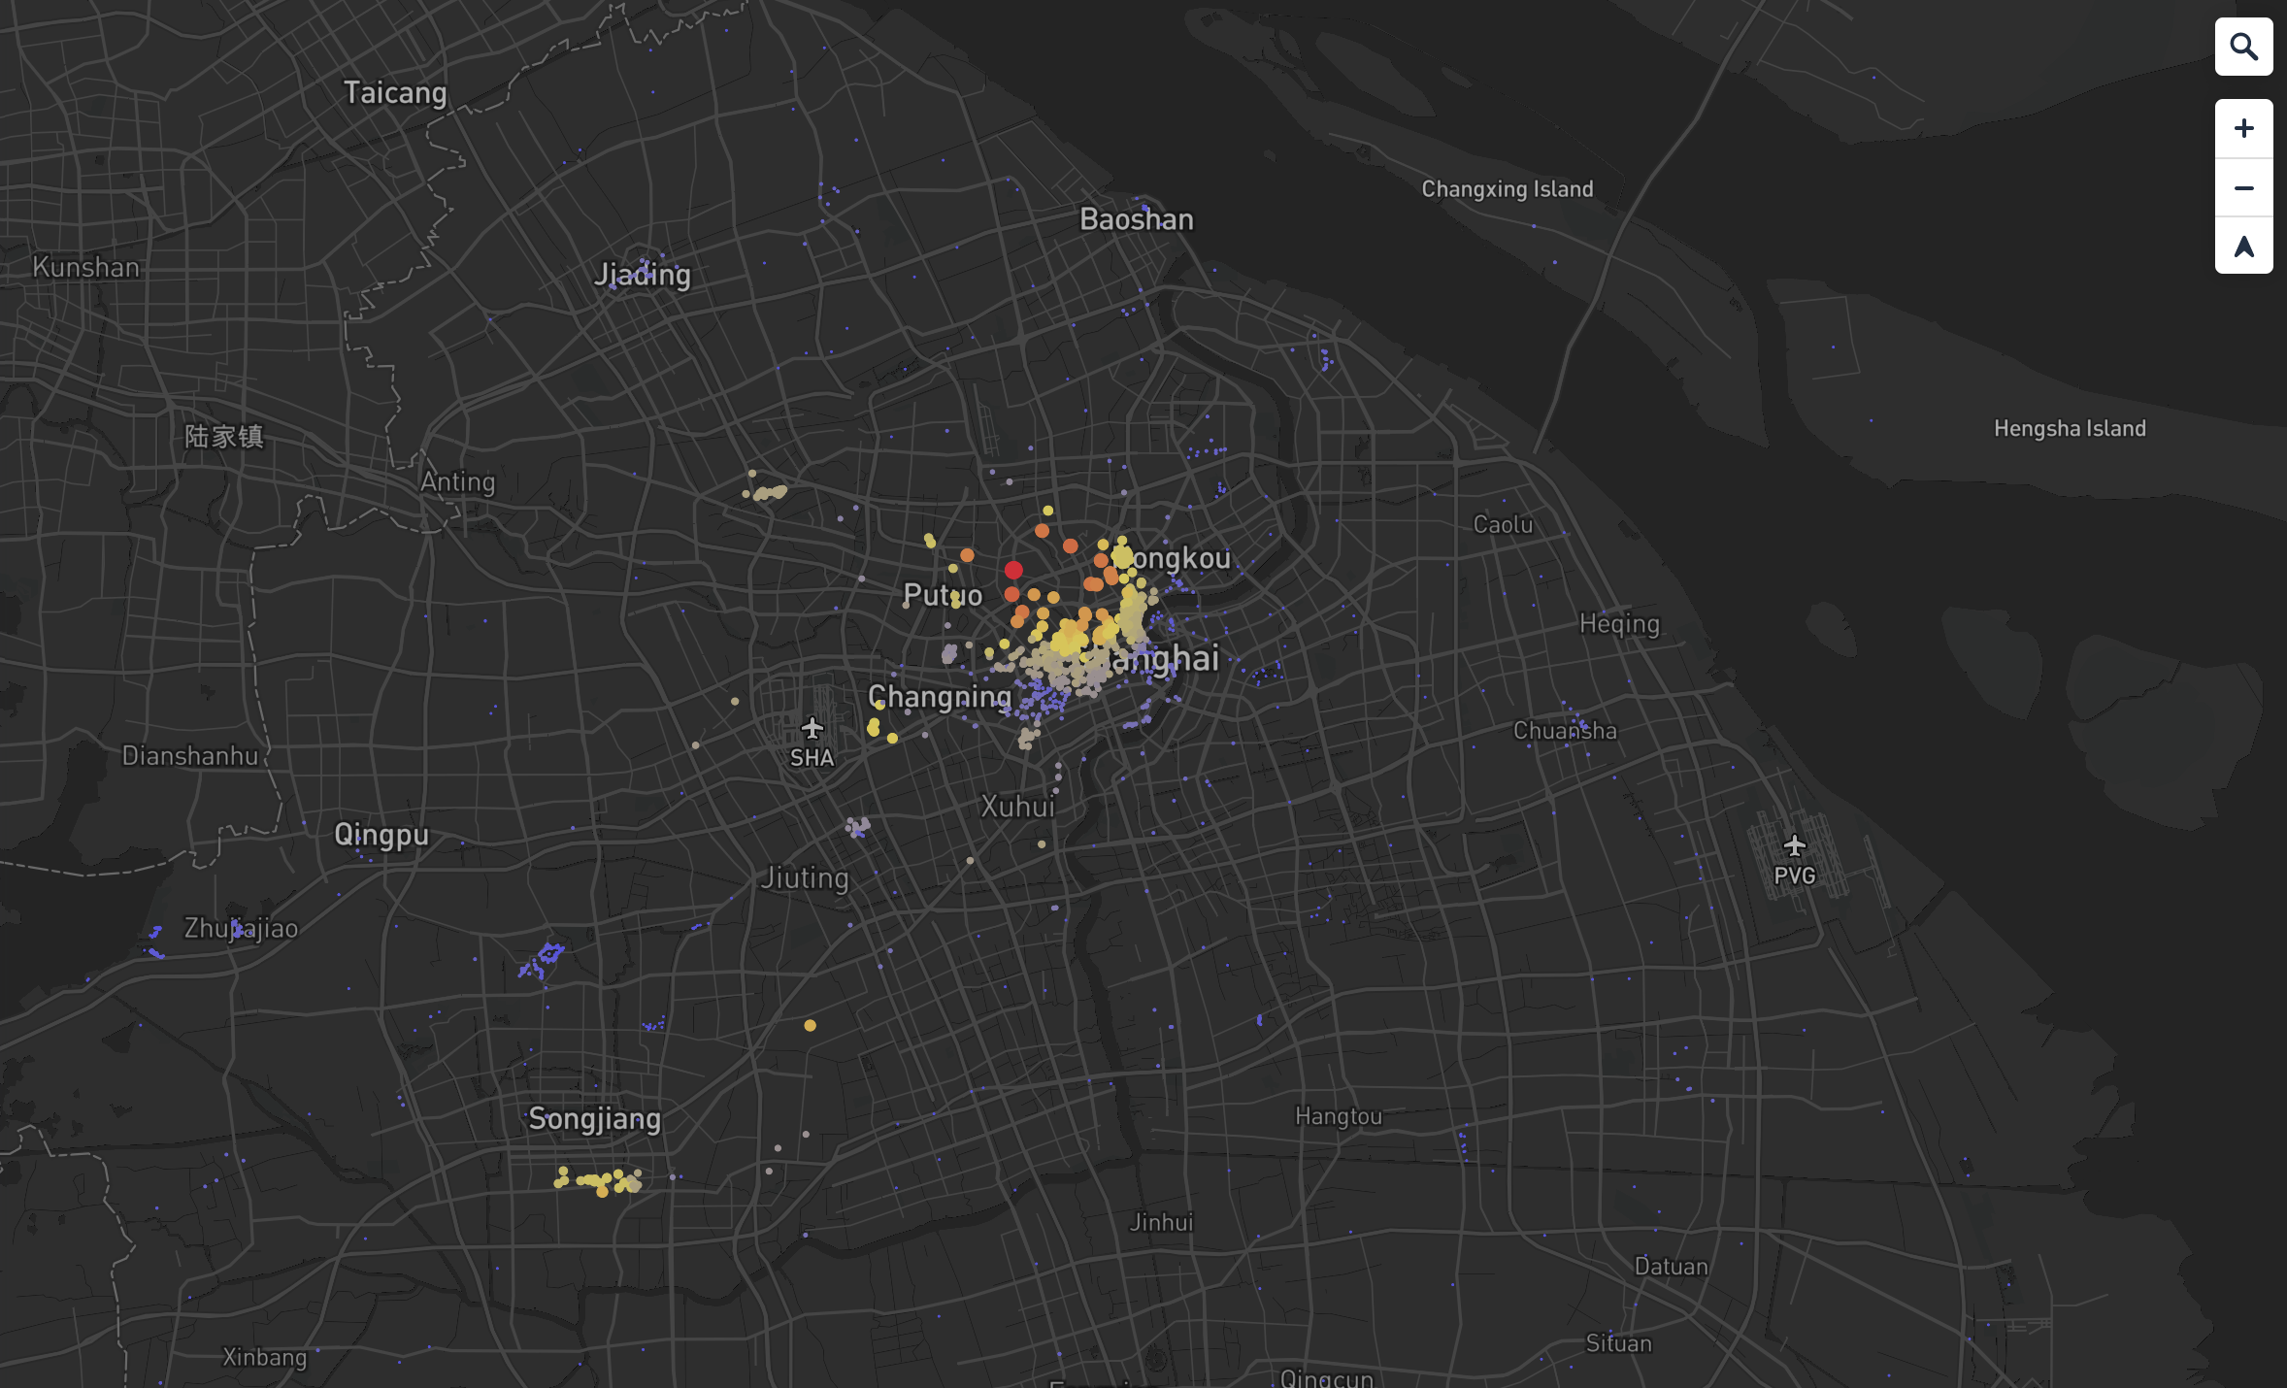

On the other hand, the other two layers are surface data, representing service areas (also called isochronous circles), that is, areas containing all traffic streets. Taking the 3000-meter service area (red) as an example, it means that the distance from any point in the area to the nearest scenic spot is less than or equal to three kilometers. The 5000-meter service area is indicated in yellow. This module uses ArcGIS for analysis, based on the urban road network, analyzes the service range of scenic spots, and is used to evaluate the convenience from the external transportation facilities in Shanghai to the scenic spots. This can help tourists who were already in Shanghai to understand the accessibility to various attractions.

